CanCentra 2.0 Trading App Review - Legit Or NOT?

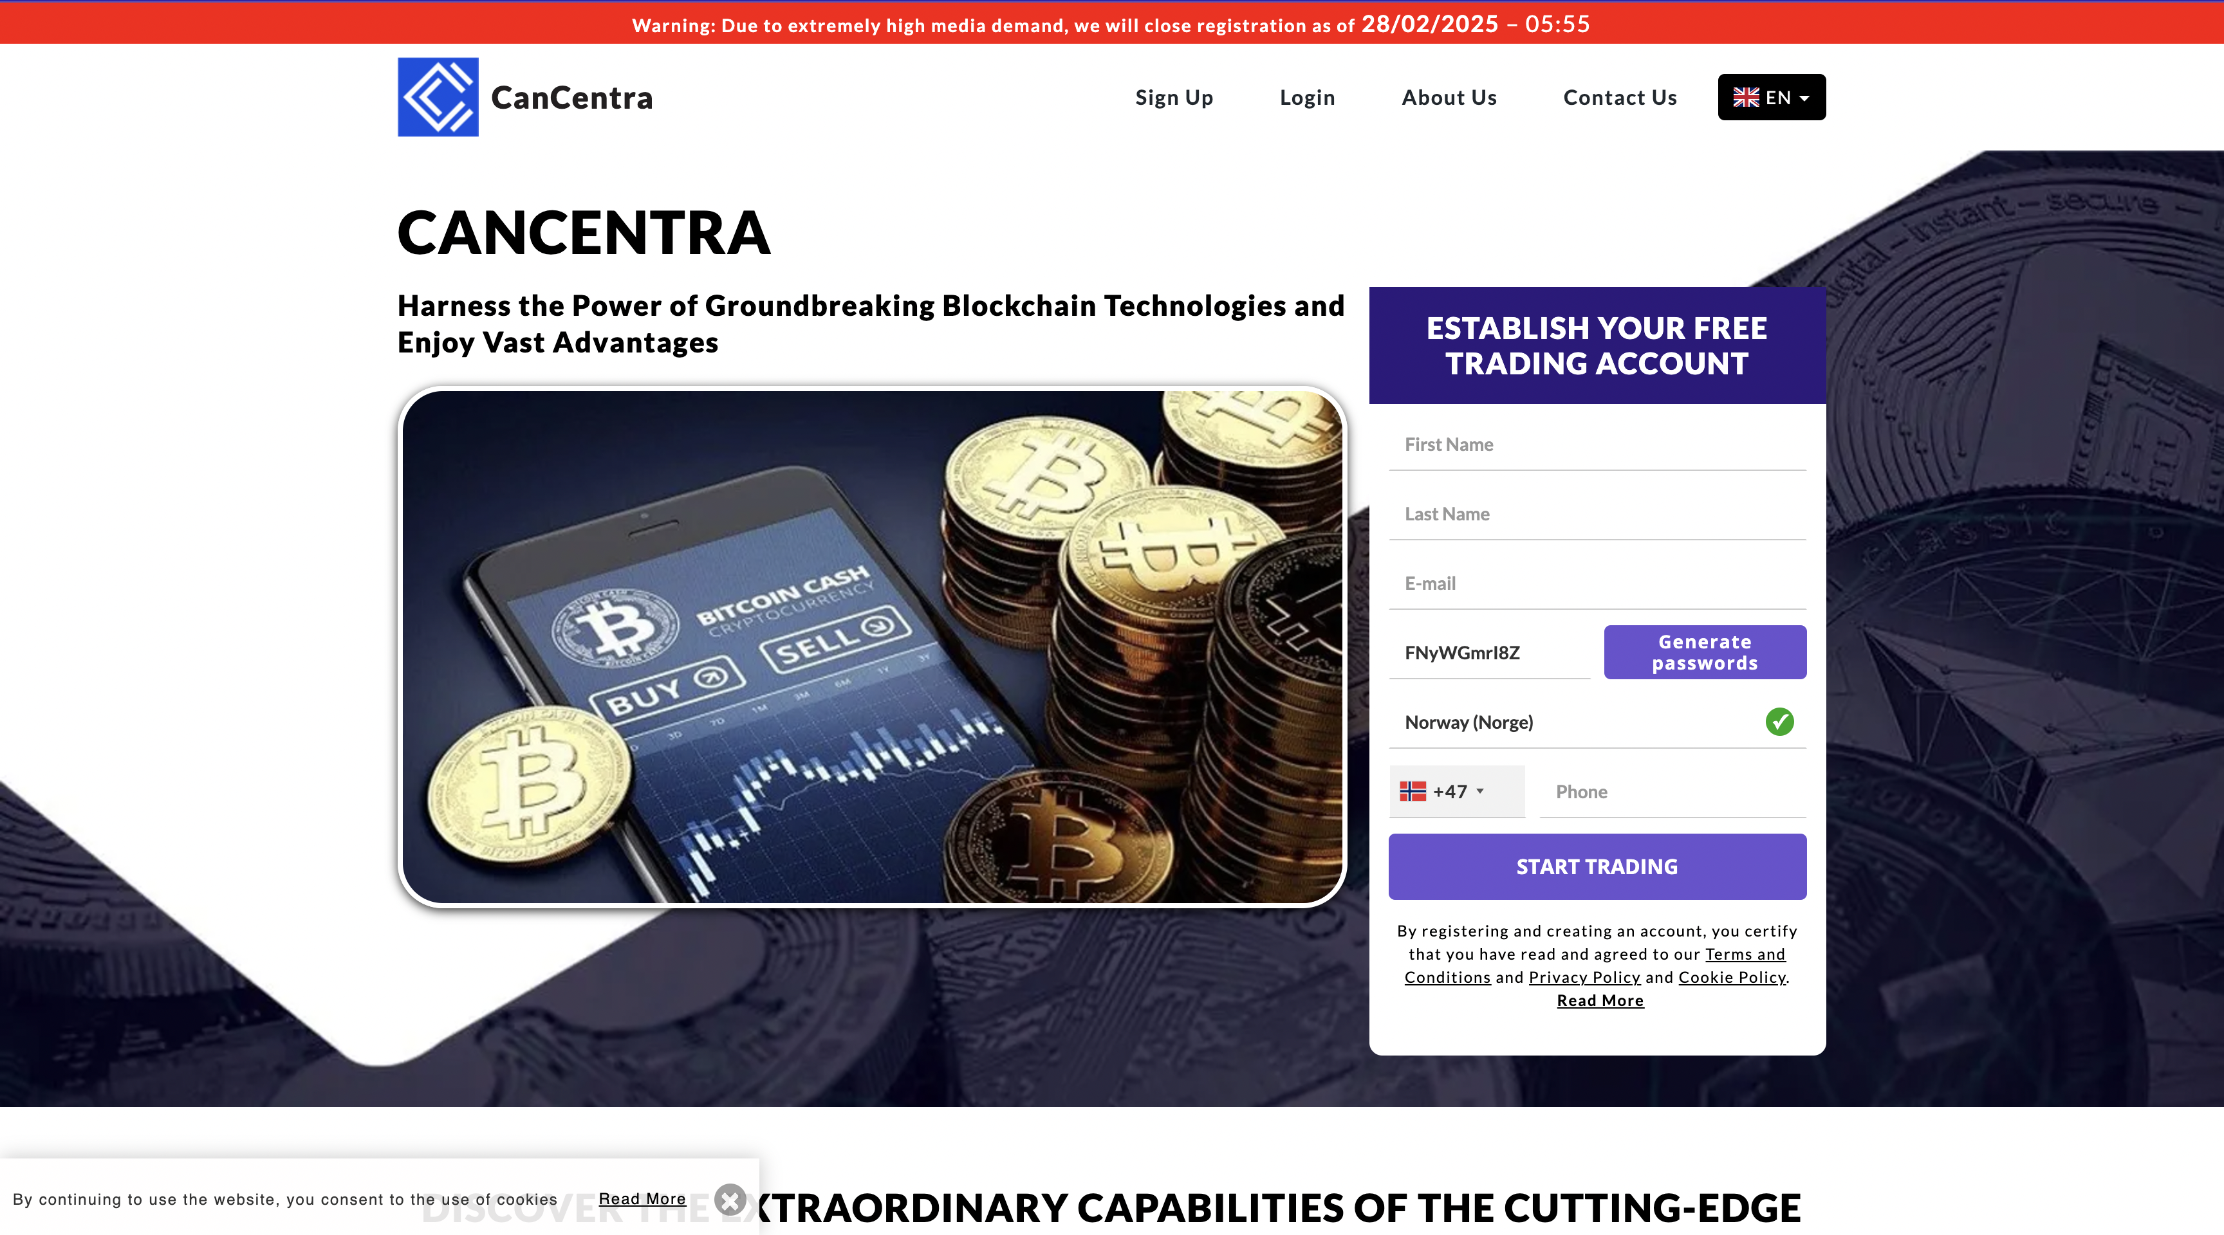

CanCentra 2.0 - It’s amazing to know that so much has occurred ever since cryptocurrency emerged and people began trading online. However, recent advancements in trading applications and platforms made it easier for people to trade without much hassles.

It also allowed traders to access the markets better, gaining advanced insights and making informed decisions. Within the advancements, we’re focusing on the CanCentra 2.0 trading app. CanCentra 2.0 is an online platform for cryptocurrency trading that has gained quite an impression from its users.

**[Explore the CanCentra 2.0 Platform](https://cancentra20.ca/)**

We’re here to illustrate how the CanCentra 2.0 app works, what are some of its features and what elements one needs to know. This CanCentra 2.0 review will surely help you understand everything with an in-depth perspective. So, without further ado, let’s get started:

## What is CanCentra 2.0 App?

Similar to trading applications running in the market, the [CanCentra 2.0](https://cancentra20.ca/) app is based on artificial technology. This technology is responsible for successfully running the algorithm for the platform that allows users to trade conveniently.

The platform/ app allows users to invest in cryptocurrency and use it to trade and earn money online via trading. The reason why applications like the CanCentra 2.0 were created was to allow users to invest and trade using multiple crypto tokens over blockchain technology.

The anonymous nature of blockchain technology invited a lot of interest, which eventually led to the creation of trading applications. Hence, CanCentra 2.0 is amongst these that have been chosen for trading purposes and is doing amazingly well.

## How Does It Work?

As highlighted earlier, the CanCentra 2.0 app is responsible for helping traders work on cryptocurrency trading and earning money online. It’s done via the algorithm that has been designed to ensure users receive accurate signals.

These signals are responsible for running the trading on the platform. What the signals mean is that they collect information based on the insights from the market and then illustrate them to the traders. Ultimately, when the signals are observed, the users become aware and make sound decisions.

**[Explore the CanCentra 2.0 Platform](https://cancentra20.ca/)**

## CanCentra 2.0 App Review

Just like other trading applications, reviewing CanCentra 2.0 is important and for that, we made sure to find out the important participles about it. We run hands-on experiences to know what the app is about and how the users can benefit from it. Here are some positives that we were able to find out about the app:

### Easy to Install

One of the best things about the application is that it’s easily available for downloads and can be installed on any device, android or iOS. It’s quite important since people prefer using applications so that they can run trading or observe the market in real-time.

Many online trading platforms don’t feature trading applications because they’re not able to maintain the app. However, the CanCentra 2.0 app is functioning properly and features the same competitive insights as in the platform.

### A Good Start To Trading

One of the best things about the platform and the app is that it’s a great start for trading not only for professional traders but also for amateurs. It features different trading styles such as demo accounts and manual accounts.

The demo account allows users to run trading on virtual demo money. This safeguards new users from spending their money on real trading operations and then losing it due to mistakes. On the other hand, pro users can use the manual mode to experience the real trading experience.

### Lead Pattern Algorithm

A good reason for sticking with the CanCentra 2.0 trading app was because of the amazing trading algorithm that we found to be quite useful. The pattern made it easier for traders to achieve new signals and find the best trading insights.

Ultimately, the trading pattern made it easier for the users to determine solid decisions. Plus, when it comes to trading, having accurate signals is the first thing that one must consider when choosing such platforms.

In this case, the CanCentra 2.0 app provided effective leading patterns that allowed us to determine the right signals. In the end, the trading practices were quite useful.

### Good Income Generation

The last important participle is income generation. We came across several users online that were using the CanCentra 2.0 app and found out that they were earning a handsome amount. The per-user generation, with a manual account and professional trading practices, generated approx. $5000 a day, which was quite an amount.

However, it’s to note that this amount isn’t something that everyone will be able to earn. Even as experienced traders, we weren’t able to generate such an amount; however, it doesn’t mean it’s impossible.

Crypto trading is extremely volatile, which is why earning such amounts is based on trading decisions. If done right, only then you can expect to have such an earning.

### Safety and Security

One of the many reasons why users don’t work with trading applications is because they ask for information regarding payment and banking methods. However, the CanCentra 2.0 app features immense security features that safeguard the information provided by the users during the registration phase.

In addition to this, the customer service from the application is also robust enough to offer support service 24/7. In case of any issue, the users are requested to contact support and ask for assistance.

Even in case of general queries, the customers can contact and will get an instant response. We tried this during our inspection and found the customer support representative to offer assistance almost instantly.

## How To Register With CanCentra 2.0 App?

Now that, you’ve known how the application works, it’s time to get started with the application. The process is fairly simple and one can complete registration without much hassle. So, let’s check out the process:

### Registering With the Site

The registration phase begins with visiting the website for CanCentra 2.0. The users are allowed to read through the policies and regulations that are listed on the site. This is to ensure that everything comes to the knowledge of the users and nothing goes by unattended.

**[Explore the CanCentra 2.0 Platform](https://cancentra20.ca/)**

### Adding Funds

Just like other applications and trading platforms, we found out that the CanCentra 2.0 app requires an initial investment amount. The amount submitted was $250, which is the minimum amount that all users must add to successfully register their account with CanCentra 2.0.

The initial amount is taken so that the users are officially registered, and that only users with legitimate payment details are added to the platform. Plus, this initial investment amount is converted into virtual money, which is later used for trading purposes.

### Choosing the Account

Once the account is funded with the initial investment, the users are allowed to choose between demo and manual accounts. The demo account is for those that want to learn to trade and are amateurs when it comes to determining signals.

On the other hand, the manual account is for those that are professionals in trading and already know how trading platforms and signals work. However, one thing to note is that if you’re not versed with trading practices, there’s no use in running a manual account.

That means, it’s important you choose a demo account, learn trading via featured trading tutorials on the platform, and then switch to a manual account for the purpose. In case you choose to trade directly, you’re likely to lose money.

## Is CanCentra 2.0 App A Scam?

The primary question that we were initially concerned with is whether the CanCentra 2.0 app is a scam or not. According to the site’s details and the experiences shared by the users that are earning on the platform, the application is legit and features great opportunities for earning.

Most users have experienced losses primarily because they’re not versed with how trading works and how to read signals. As experienced traders, we were able to earn almost 80% return on our initial investment in a day.

However, with a demo account, the users can learn how trading practices work, which in return equips them with the knowledge for trading. Most of the users often invest in the trading platform and with their initial investment, they turn into manual trading right away.

Even though some technical glitches can occur at the end of the application. However, these are minor issues and are fixed right away. Running such a vast application requires immense calibration and the app’s creators have input the same effort to ensure such glitches are mitigated.

## Why Choose CanCentra 2.0?

The reason why the CanCentra 2.0 app is most preferred by numerous traders from around the globe is because of its intelligent market monitoring mainframe. This mainframe comprises an algorithm that runs the app, collects market insights 24/7, and provides them in real time to the users.

The amazing element that we observed about the app is that it features trillions of dollars traded every day, which shows that the application is working superbly well. As per our experience, everything remained reliably well too.

## Frequently Asked Questions

Here are some frequently asked questions about the CanCentra 2.0 app that will help understand more about it:

### Is The CanCentra 2.0 App Suitable For Beginners?

Yes, the CanCentra 2.0 app features a demo mode for trading, after you’ve added funds to it. Once the demo account is chosen, the users are directed to virtual training trading. This mode makes it easier for beginner users to experience trading without having to risk their initial investment. Once the users have completed their training, they can switch to manual trading and use their money for the purpose.

### Is Investment In CanCentra 2.0 A Risk?

All kinds of investments are at risk based on the workability of the users. Even if you’re investing in some other app, you’re likely to lose or earn money based on how you trade. Therefore, learning to trade is important before you invest in anything.

### Is Registration Free With CanCentra 2.0?

The registration process with CanCentra 2.0 is not free and an initial investment of $250 is needed. However, CanCentra 2.0 does offer free spots in a lucky draw. You can visit the website for its registration form and can enroll yourself in a draw to claim the chance of having a free spot.

### How Long Is The Trading Process?

The reason why the CanCentra 2.0 app is so reputed amongst the users is because of its trading practices that require a minimal time of 20 minutes only. It mitigates the need for users to quit their jobs or put all their eggs in one basket. The users can invest an hour of their time from their day and trade accordingly.

### Is CanCentra 2.0 a Scam?

No, CanCentra 2.0 is not a scam and runs a legit crypto trading market. The users are encouraged to learn trading practices before they dive into actual trading. Once this is done, the users are able to perform competitive trading decisions and earn money.

### Is CanCentra 2.0 Secure?

The CanCentra 2.0 app features reliable security features and makes it easier for users to secure their investments and personal information. The data requested during the registration phase is only used for registering the users and is kept secure with high-end security parameters.

### Should I Use CanCentra 2.0 Full-Time?

Using CanCentra 2.0 is based on your discretion. If you think you can earn a good amount of money via trading and understand what trading is about, then you can go for it. However, if you’re using CanCentra 2.0 only for kitchen money, then it’s not recommended that you use fit full-time. An hour of your day is required to monitor trading and take decisions.

## Closing Notes

Well, there you have it! We just provided an in-depth review of the CanCentra 2.0 trading app. Our reviewers have focused on running the application in every manner. From testing the demo account to using manual mode for earning money, we went through the interface and found the app to be quite useful. Again, it’s recommended that the users learn trading practices first and then switch to manual trading mode. In that case, one can know what causes their trading decisions to fall short, which is a rare occurrence.

**[Explore the CanCentra 2.0 Platform](https://cancentra20.ca/)**